BLINKING OF AN LED USING ARDUINO
Date:

Aim:
To interface an LED with Arduino and to write a program to make the LED blink at defined intervals.

Components required:
- PC or laptop
- Arduino UNO
- 220 resistor
- LED
- Breadboard
- Connecting wires
Software required:
- Arduino IDE
Connections:
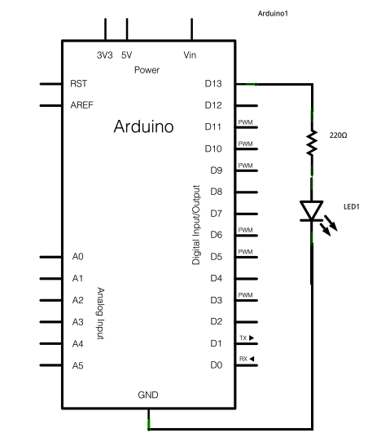
- Connect the longer leg of the LED, that is the anode, to the digital pin 13 in the Arduino, through a 220 resistor.
- Connect the shorter leg of the LED, that is the cathode, to the ground (GND) pin on the Arduino.
Procedure:
- Connect the components on a breadboard as mentioned above and connect the Arduino to the PC/laptop.
- Open Aurdino IDE and open a new editor.
- Enter the required code save it as a “ino” file.
- In the “Tools” menu go to the “Port” tab and select the appropriate port.
- Upload the program into the Arduino and verify the output.
Program:
To make the built-in LED blink:
void setup() {
// initialize digital pin LED_BUILTIN as an output.
pinMode(LED_BUILTIN, OUTPUT);
}
// the loop function runs over and over again forever
void loop() {
digitalWrite(LED_BUILTIN, HIGH); // turn the LED on (HIGH is the voltage level)
delay(1000); // wait for a second
digitalWrite(LED_BUILTIN, LOW); // turn the LED off by making the voltage LOW
delay(1000); // wait for a second
}
To make the externally connected LED blink:
int led = 13;
void setup() {
// initialize digital pin LED_BUILTIN as an output.
pinMode(led, OUTPUT);
}
// the loop function runs over and over again forever
void loop() {
digitalWrite(led, HIGH); // turn the LED on (HIGH is the voltage level)
delay(1000); // wait for a second
digitalWrite(led, LOW); // turn the LED off by making the voltage LOW
delay(1000); // wait for a second
}

Result:
A program has been written to make the built-in and externally connected LED blink and the output verified.

